Deploy a 3 Tier Architecture Webapp on AWS

Architecture overview

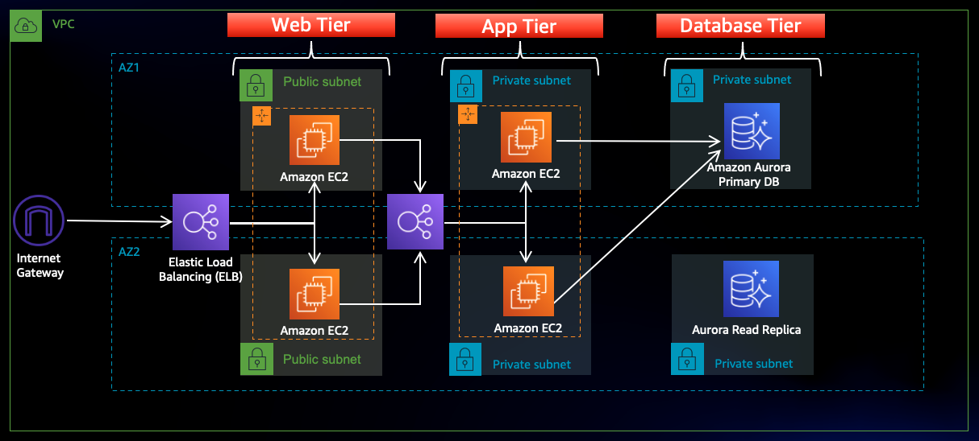

In this architecture, a public-facing Application Load Balancer forwards client traffic to our web tier EC2 instances. The web tier is running Nginx webservers that are configured to serve a React.js website and redirects our API calls to the application tier’s internal facing load balancer. The internal facing load balancer then forwards that traffic to the application tier, which is written in Node.js. The application tier manipulates data in an Aurora MySQL multi-AZ database and returns it to our web tier. Load balancing, health checks and auto scaling groups are created at each layer to maintain the availability of this architecture.

Setup

In this task we will be downloading the code from Github (<https://github.com/aws-samples/aws-three-tier-web-architecture-workshop.git> ) and upload it to amazon S3 bucket so our instances can access it. We will also create an AWS Identity and Access Management EC2 role so we can use AWS Systems Manager Session Manager to connect to our instances securely and without needing to create SSH key pairs.

* S3 Bucket Created and named **mywebapp-ashish-101**
* Created IAM EC2 Instance role and named **Project-ec2role**

Permission policies **AmazonSSMManagedInstanceCore and AmazonS3ReadOnlyAccess** added to **Project-ec2role**

Networking and Security

* **VPC**

- Project-vpc with IPV4 CIDER (10.0.0.0/16)

* **Subnets**

To achieve high availability we have created subnets in two different zones

- Public-Web-Subnet-AZ1 (10.0.0.0/24)

- Public-Web-Subnet-AZ2 (10.0.1.0/24)

- Private-App-Subnet-AZ1 (10.0.2.0/24)

- Private-App-Subnet-AZ2 (10.0.3.0/24)

- Private-DB-Subnet-AZ1 (10.0.4.0/24)

- Private-DB-Subnet-AZ2 (10.0.5.0/24)

* **Internet connectivity**

To give the public subnets in our VPC internet access we have created internet gateways **(“Project-IGW”)** and attached to our VPC “**Project-vpc**”.

**NAT Gateway**

We will use NAT Gateway for private Instances to access internet through the secure gateway channel. We have created two NAT gateways **(NAT-GW-AZ1, NAT-GW-AZ2)** due to multi AZ.

* **Routing Configuration**

We have created three route tables as given below:

**PublicRouteTable**

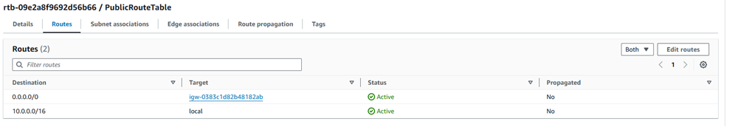

**PrivateRouteTableAZ1**

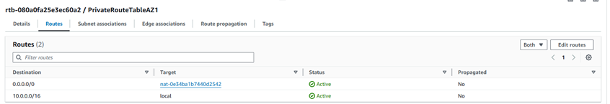

**PrivateRouteTableAZ2**

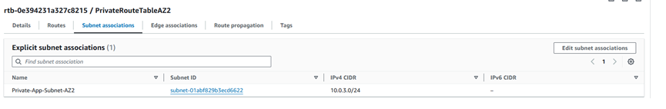

* **Security Groups**

We will create some Security groups which will filter the traffic be to our Elastic Load Balancers and EC2 instances. So we have created security groups as given below

-WebTierSG

-Privateinstances-sg

-DB-SG

-Internet-facing-lb-sg

-Internal-lb-sg

Database Deployment

* Subnet Groups created **“project-db-subnet-group”**
* Database Deployment **“ArouraDB/MySQL”**

RDS Writer endpoint “**database-1-instance-1.cznsyzczkkou.us-east- 1.rds.amazonaws.com”**

App Tier Instance Deployment

* **App Instance Deployment**

-Launched an EC2 instance with Amazon Linux image named as App-server

* **Connect to Instance**

-Connected to app-server using session manager.

-Login as ec2-user

* **To Configure Database we will use the following commands**

*-sudo wget* [*https://dev.mysql.com/get/mysql57-community-release-el7-11.noarch.rpm*](https://dev.mysql.com/get/mysql57-community-release-el7-11.noarch.rpm)

*-sudo rpm --import* [*https://repo.mysql.com/RPM-GPG-KEY-mysql-2022*](https://repo.mysql.com/RPM-GPG-KEY-mysql-2022)

*-sudo yum install* [*https://dev.mysql.com/get/mysql57-community-release-el7-11.noarch.rpm*](https://dev.mysql.com/get/mysql57-community-release-el7-11.noarch.rpm)

-*sudo yum install mysql –y*

-**To Initiate DB connection with your Aurora RDS writer endpoint. In the following command, we will replace the RDS writer endpoint and the username, and then execute it in the browser terminal:**

*mysql -h database-1-instance-1.cznsyzczkkou.us-east-1.rds.amazonaws.com -u admin -p*

*-CREATE DATABASE webappdb;*

*-SHOW DATABASES;*

*-USE webappdb;*

**To create the transactions table we will use this create table command:**

-*CREATE TABLE IF NOT EXISTS transactions(id INT NOT NULL*

*AUTO_INCREMENT, amount DECIMAL(10,2), description*

*VARCHAR(100), PRIMARY KEY(id));*

-*SHOW TABLES;*

**To insert data into the table we will use the following command**

*-INSERT INTO transactions (amount,description) VALUES ('400','groceries');*

**To verify if the data was added by executing the following command:**

-*SELECT * FROM transactions;*

* **Configure App Instance**

We will upload the app-tier files to our S3 bucket (**mywebapp-ashish-101)** before upload files we need to modify the DbConfig.js file. After upload the app-tier folder to **mywebapp-ashish-101** we need to install all of the necessary components to run our backend application.

**Start by installing NVM (node version manager).**

*-curl -o- https://raw.githubusercontent.com/nvm-sh/nvm/v0.38.0/install.sh | bash*

*-source ~/.bashrc*

*-nvm install 16*

*-nvm use 16*

**We will also install PM2 a daemon process manager which will keep our node.js app running when we exit the instance or if it is rebooted.**

*-npm install -g pm2*

**We need to download our code from our s3 buckets onto our instance. To download our code we will use this command**

*-cd ~/*

*-* *aws s3 cp s3://mywebapp-ashish-101/app-tier/ app-tier –recursive*

*-ls –lrt* tocheck if the code has downloaded

*-cd app-tier*

*-npm install*

*-pm2 start index.js*

*-pm2 list* To make sure the app is running correctly

*-pm2 logs* To check if app shows error

*-* *pm2 startup*

*-pm2 save*

* **Test App Tier**

**-***curl* [*http://localhost:4000/health*](http://localhost:4000/health)should show result as



-*curl* [*http://localhost:4000/transaction*](http://localhost:4000/transaction) *should show*



Internal Load Balancing and Auto Scaling

* **App Tier AMI**

Created App tier AMI from the App-servernamed as **“App-sever image”**

* **Target Group**

Created target group for the app tiernamed as **AppTierTargetGroup**

* **Internal load Balancer**

Created internal load balancer as **“Internal-Loadbalancer”**

* **Launch Template**

Created launch template app tier named as **“Apptier-Launchtemplate”**

* **Auto Scaling**

Created auto scaling group named as **App-Tier-ASG**

Web Tier Instance Deployment

* **Update Config File**

Before create and configure the web instances, we need to update **application-code/nginx.conf** file from the repo we downloaded. We need to replace [INTERNAL-LOADBALANCER-DNS] with our internal load balancer’s DNS.

* **Web Instance Deployment**

Launched EC2 instance with Amazon Linux image names as Web-sever under our project-vpc using Web-Tier subnet.

* **Connect to Instance**

-Connected to Web-server using session manager.

-Login as ec2-user

* **Configure Web Instance**

We need to install all of the necessary components needed to run our front-end application.

*-curl -o- https://raw.githubusercontent.com/nvm-sh/nvm/v0.38.0/install.sh | bash*

*-source ~/.bashrc*

*-nvm install 16*

*-nvm use 16*

**To download web** tier code from our s3 bucket use the following command

*-aws s3 cp s3://mywebapp-ashish-101/web-tier/ web-tier –recursive*

**Navigate to the web**-layer folder and create the build folder for the react app so we can serve our code:

*-cd web-tier*

*-npm install*

*-npm run build*

**We are using ngnix** as a web server that we will configure to serve our application on port 80, as well as help direct our API calls to the internal load balancer.

-*Sudo yum install ngnix -y*

**Now we will configure** ngnix by using the following commands:

*cd /etc/nginx*

*ls*

*sudo rm nginx.conf (make sure to make a backup of ngnix.conf before delete it)*

*sudo aws s3 cp s3:// mywebapp-ashish-101/nginx.conf*

*sudo service nginx restart*

*chmod -R 755 /home/ec2-user*

*sudo chkconfig nginx on*

External Load Balancer and Auto Scaling

* **Web Tier AMI**

Created Web Tier image named as Web-serverImange



* **Target Group**

Created target group as **WebTargetGroup**

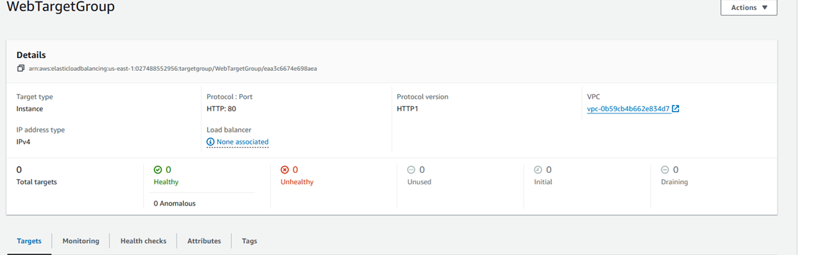

* **Internet Facing Load Balancer**

Created internet facing Loadbalancer **(“ExternalLoadBalancer”)** to server our frontend web application on HTTP and HTTPS ports. So clients will hit the URL ExternalLoadbalancer-817560048.us-east-1.elb.amazonaws.com to access our frontend application and this Loadbalancer will distribute the traffic to multiple instances running application on.



* **Launch Template**

Created WebTierLaunchTemplate using **Web-serverImage**

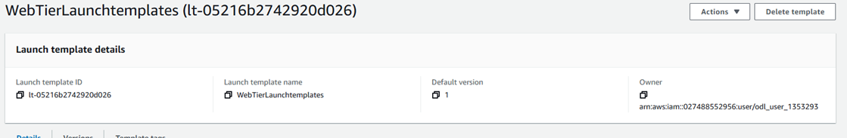

* **Auto Scaling**

Created **Web-Tier ASG** using WebTierLaunchTemplate and defined the desired capacities as given below.

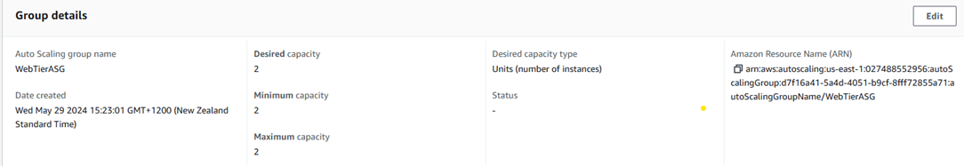

**References:-**

<https://catalog.us-east-1.prod.workshops.aws/workshops/85cd2bb2-7f79-4e96-bdee-8078e469752a/en-US/part6/createami>

[Project2 - Deploy a 3 Tier Architecture On AWS - End to End Project Demo (youtube.com)](https://www.youtube.com/watch?v=amiIcyt-J2A&list=PLl4APkPHzsUUc8HOEIwfB3Z2uxRv2SKOG&index=3)